**CS120 IS THE BEST MODULE EVER**

**Note: I have no idea what will be tested in the exam. Some of these questions are quite troll so don’t spend too much time on it if you haven’t revised yet. Again, please manage your time well. The practice paper Edward provided should be more than sufficient. This is just extra practice if you guys want to try.**

1. Given the following variables, write the outputs of the subsequent print statements:

char c = ‘a’;

const char* cc = “ba chor mee”;

printf("%d\n", 5.00);

__________________________________________________________

printf("%d%f\n", 4, .4f);

__________________________________________________________

printf("%%d%d\\%d/n%s\n", 4, c, cc);

__________________________________________________________

printf("%%d printf %d", printf("\"cs120 is easy!\" ")); __________________________________________________________

printf("\"%%f, %""%f\""",%2f", 3.5f, .5f, 1.2f);

___________________________________________________________

1. Write the type of the following statements.

If there is a COMPILE error, write NC.

If there is a RUNTIME error, write ERROR.

void* v = NULL;

int i = 4;

char c = 'a';

int* pi = &i;

int* ppi = NULL;

int* ci = &c; ___________________________

pi = ppi; ___________________________

int a = *ppi; ___________________________

v = pi; ___________________________

v = &pi; ___________________________

pi = *ppi; ___________________________

1. Function declaration. I’m sure you guys are familiar with these types of questions. It’s free marks so do practice them…

Declare the function foo that takes in a pointer to an integer and a double.

Declare a function boo that takes in 2 pointers to int and returns a void pointer.

Declare a pointer baz that points to the 3rd element of the 5th element of the variable:

int* b[10][20]; /* Determine the type of baz yourself */

Declare a function boo that takes in 2 pointers and returns nothing. The first points to void, the second points to an array of 20 arrays of pointer to chars.

1. Answer the question based on the code below. Assume the address of edward is 1000. (Assume the return 0 ; is there. I am too lazy to screenshot again)

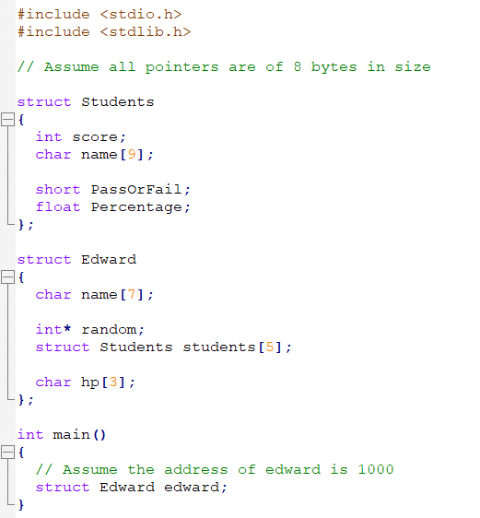

1. sizeof(struct Students)
2. sizeof(struct Edward)
3. &edward.name[5]
4. &edward.students[0]
5. &edward.students[0].score
6. &edward.students[3].PassOrFail
7. &edward.students[2].name[3]
8. &edward.hp[1]
9. Write the output of the following programs.

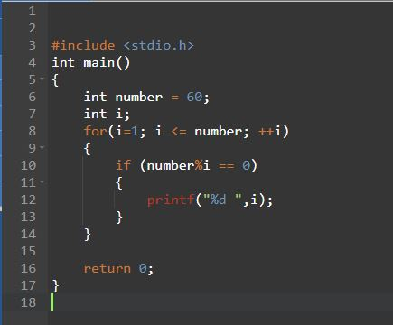

Output: ______________________________________

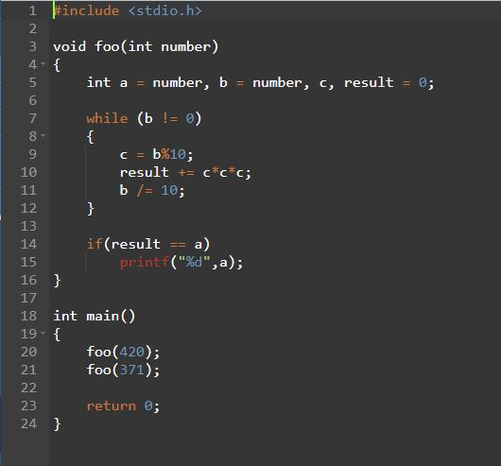

Output: ___________________________________________

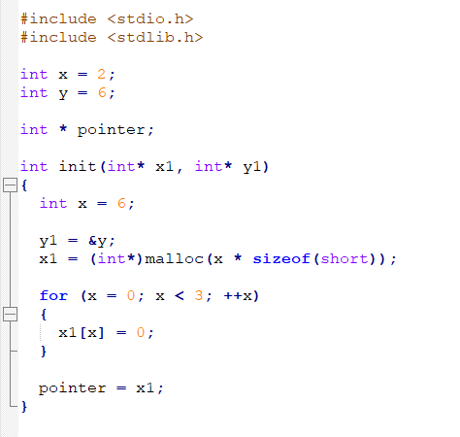

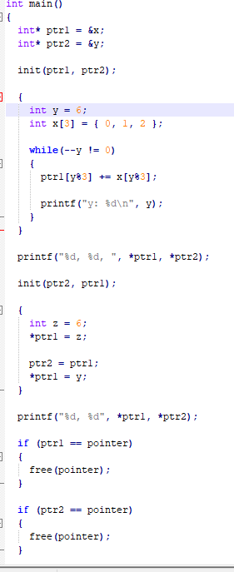

Output: ___________________________________________

How many bytes memory leak is there? _________________

Programming questions:

1. Write a program that checks if a string is a palindrome or not. A palindrome is a word that is the same whether it is read from the front or the back. Eg: "RACECAR" is a palindrome. "MOTHER" is not a palindrome. "EDWARD" could be a palindrome if he changes his name.
2. Write a program that displays the Fibonacci sequence. The Fibonacci sequence goes like this: n0, n1, n2, n3, ….. n(n-2) + n(n-1) where n0 = 0 and n1 = 1. So first 10 numbers are: 0, 1, 1, 2, 3, 5, 8, 13, 21, 34.
3. Write a function that takes in 3 ints and returns the largest of the 3 ints. You cannot use if-else statements. Note: try doing it with first. If you can’t, please don’t waste too much time doing these questions.
4. Write the function definition of strcmp. Here is the function declaration:

int strcmp(const char* str1, const char* str2);